Topic: Storage classes

- Generally there are two kinds of locations in a computer where such a value can be present, these are Memory and CPU registers. The storage class of a particular variable determines in which of the above two locations the variable‘s value is stored.
- There are four properties by which storage class of a variable can be recognized. These are scope, default initial value, scope and life.
- A variable‘s storage class reveals the following things about a variable
- Where the variable is stored.
- What is the initial value of the variable if the value of the variable is not specified?
- What is the scope of the variable (To which function or block the variable is available).
- What is the life of particular variable (Up to what extent the variable exists in a program).

  - In c there are four types of storage class. They are: 1. Auto 2. Register 3.
Static 4. Extern
  - Storage class is modifier or qualifier of data types which decides: In which area of memory a particular variable will be stored? What is scope of variable? What is visibility of variable?

Visibility of a variable in c: Visibility means accessibility. Up to witch part or area of a program, we can access a variable, that area or part is known as visibility of that variable. For example: In the following figure yellow color represents visibility of variable a.

Scope of a variable in c: Meaning of scope is to check either variable is alive or dead. Alive means data of a variable has not destroyed from memory. Up to which part or area of the program a variable is alive, that area or part is known as scope of a variable. There are four type of scope in c:
- Block scope.
- Function scope.
- File scope.
3. Program scope.
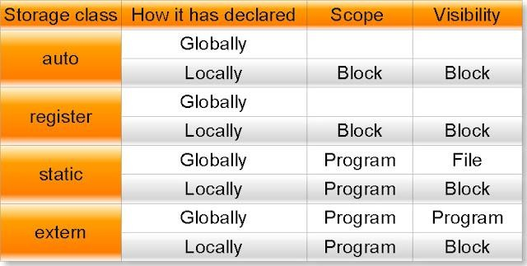

Automatic Storage Class
Syntax to declare automatic variable is: auto datatype variablename;
Example:
auto int i;
Features of Automatic Storage Class are as follows
Storage: Memory
Default Initial Value: Garbage Value
Scope: Local to the block in which the variable is defined
Life: Till the control remains within the block in which the variable is defined by default every variable is automatic variable
The following program illustrates the work of automatic variables. void test();
void main()
{
test();
test();
test();
}
void test()
{
auto int k=10; printf(―%d\n‖,k); k++;
}
Output:
10
10
10
In the above program when the function test() is called for the first time ,variable k is created and initialized to 10. When the control returns to main(), k is destroyed. When function test() is called for the second time again k is created , initialized and destroyed after execution of the function. Hence automatic variables came into existence each time the function is executed and destroyed when execution of the function completes.

Register Storage Class
Syntax to declare register variable is:
register datatype variablename;
Features of Register Storage Class are as follows:
Storage: CPU Registers
Default Initial Value: Garbage Value
Scope: Local to the block in which the variable is defined
Life: Till the control remains within the block in which the variable is defined
For example loop counters are declared as register variables, which are defined as follows: int main()
{
register int a; for(a=0;i<50000;i++) printf(―%d\t‖,a); return 0;

In the above program, variable a was used frequently as a loop counter so the variable a is defined as a register variable. Register is a not a command but just a request to the compiler to allocate the memory for the variable into the register. If free registers are available than memory will be allocated in to the registers. And if there are no free registers then memory will be allocated in the RAM only (Storage is in memory i.e. it will act as automatic variable).
Every type of variables can be stored in CPU registers. Suppose the microprocessor has 16 bit registers then they can‘t hold a float or a double value which requires 4 and 8 bytes respectively.
But if you use register storage class for a float or double variable then you will not get any error message rather the compiler will treat the float and double variable as be of automatic storage class(i.e. Will treat them like automatic variables).

Static Storage Class
Syntax to declare static variable is:
static datatype variablename; Example:
static int i;
Features of Static Storage Class are as follows
Storage: Memory

Default Initial Value: Zero
Scope: Local to the block in which the variable is defined
Life: Value of the variable continues to exist between different function calls
Now look at the previous program with k is declared as static instead of automatic. void test();
void main()
{
test();
test();
test();
}
void test()
{
static int k=10; printf(―%d\n‖,k); k++;
}

Output:10 11 12
Here in the above program the output is 10, 11, 12, because if a variable is declared as static then it is initialized only once and that variable will never be initialized again. Here variable k is declared as static, so when test() is called for the first time k value is initialized to 10 and its value is incremented by 1 and becomes 11. Because k is static its value persists. When test() is called for the second time k is not reinitialized to 10 instead its old value 11 is available. So now 11 is get printed and it value is incremented by 1 to become 12. Similarly for the third time when test() is called 12(Old value) is printed and its value becomes 13 when executes the statement ‗k++;‘

So the main difference between automatic and static variables is that static variables are initialized to zero if not initialized but automatic variables contain an unpredictable value(Garbage Value) if not initialized and static variables does not disappear when the function is no longer active , their value persists, i.e. if the control comes back to the same function again the static variables have the same values they had last time.

General advice is avoid using static variables in a program unless you need them, because their values are kept in memory when the variables are not active which means they occupies space in memory that could otherwise be used by other variables.

External Storage Class
Syntax to declare static variable is:
extern datatype variablename; Example:
extern int i;
Features of External Storage Class are as follows
Storage: Memory

Default Initial Value: Zero
Scope: Global
Life: Till the program‘s execution doesn‘t come to an end
External variables differ from automatic, register and static variables in the context of scope, external variables are global on the contrary automatic, register and static variables are local. External variables are declared outside all functions, therefore are available to all functions that want to use them.
If the program size is very big then code may be distributed into several files and these files are compiled and object codes are generated. These object codes linked together with the help of linker and generate ―.exe‖ file. In the compilation process if one file is using global variable but it is declared in some other file then it generate error called undefined symbol error. To overcome this we need to specify global variables and global functions with the keyword extern before using them into any file. If the global variable is declared in the middle of the program then we will get undefined symbol error, so in that case we have to specify its prototype using the keyword extern.

So if a variable is to be used by many functions and in different files can be declared as external variables. The value of an uninitialized external variable is zero. The declaration of an external variable declares the type and name of the variable, while the definition reserves storage for the variable as well as behaves as a declaration. The keyword extern is specified in declaration but not in definition. Now look at the following four statements

- auto int a;
- register int b;
- static int c;
- extern int d;
Out of the above statements first three are definitions where as the last one is a declaration. Suppose there are two files and their names are File1.c and File2.c respectively. Their contents are as follows:

File1.c
int n=10; void hello()
{
printf(―Hello‖);
}

File2.c
extern int n;
extern void hello(); void main()
{printf(―%d‖, n);
hello();}
In the above program File1.obj+ File2.obj=File2.exe and in File2.c value of n will be 10.

Module – 2: (Arithmetic expressions & Conditional Branching)

Topic: Arithmetic expressions and precedence: Operators and expression using numeric and relational operators, mixed operands, type conversion, logical operators, bit operations, assignment operator, operator precedence and associability.

OPERATORS-An operator is a symbol that tells the compiler to perform specific mathematical or logical manipulations. C language is rich in built-in operators and provides the following types of operators: Arithmetic Operators, Relational Operators, Logical Operators, Bitwise Operators, Assignment Operators, Increment and decrement operators, Conditional operators, Misc Operators

Arithmetic operator: Assume variable A holds 10 and variable B holds 20 then:

Operator | Description | Example
+ | Adds two operands | A + B will give 30
- | Subtracts second operand from the first | A – B will give -10
* | Multiplies both operands | A * B will give 200
/ | Divides numerator by de-numerator | B / A will give 2
% | Modulus Operator and remainder of after an integer  Division | B % A will give 0
++ | Increments operator increases integer value by one | A++ will give 11
-- | Decrements operator decreases integer value by one | A–will give 9

Relational Operators:
Assume variable A holds 10 and variable B holds 20, then:
Operator | Description | Example
== | Checks if the values of two operands are equal or not, if yes  then condition becomes true. | (A == B) is not  true.
!= | Checks if the values of two operands are equal or not, if values are not equal then condition becomes true. | (A != B) is true.
> | Checks if the value of left operand is greater than the value of right operand, if yes then condition becomes true. | (A > B) is not  true.
< | Checks if the value of left operand is less than the value of right operand, if yes then condition becomes true. | (A < B) is true.
>= | Checks if the value of left operand is greater than or equal to the value of right operand, if yes then condition becomes  true. | (A >= B) is not  true.
<= | Checks if the value of left operand is less than or equal to the value of right operand, if yes then condition becomes true. | (A <= B) is true.

Logical Operators:
Assume variable A holds 1 and variable B holds 0, then:
Operator | Description | Example
&& | Called Logical AND operator. If both the operands are  nonzero, then condition becomes true. | (A && B) is  false.
|| | Called Logical OR Operator. If any of the two operands is  non-zero, then condition becomes true. | (A || B) is true.
! | Called Logical NOT Operator. Use to reverses the logical  state of its operand. If a condition is true then Logical NOT  operator will make false. | !(A && B) is  true.

Bitwise Operators
Bitwise operator works on bits and performs bit-by-bit operation. These operators can operate upon int and char but not on float and double..Bit wise operators in C language are; & (bitwise AND), | (bitwise OR), ~ (bitwise OR), ^ (XOR), << (left shift) and >> (right shift).The truth tables for &, |, and ^ are as follows:
P | Q | p & q | p | q | p ^ q
0 | 0 | 0 | 0 | 0
0 | 1 | 0 | 1 | 1
1 | 1 | 1 | 1 | 0
1 | 0 | 0 | 1 | 1

Assume variable A holds 60 (00111100) and variable B holds 13 (00001101), then:
Operator | Description | Example
& | Binary AND Operator copies a bit to the result if it  exists in both operands. | (A & B) will give 12, which is 0000 1100
| | Binary OR Operator copies a bit if it exists in either  operand. | (A | B) will give 61, which is 0011 1101
^ | Binary XOR Operator copies the bit if it is set in  one operand but not both. | (A ^ B) will give 49, which is 0011 0001
~ | Binary Ones Complement Operator is unary and has  the effect of ‗flipping‘ bits. | (~A ) will give -61, which is 1100 0011 in 2‘s complement form.
<< | Binary Left Shift Operator. The left operands value is moved left by the number of bits specified by the  right operand. | A << 2 will give 240  which is 1111 0000
>> | Binary Right Shift Operator. The left operands value is moved right by the number of bits specified  by the right operand. | A >> 2 will give 15  which is 0000 1111

Assignment Operators:
In C programs, values for the variables are assigned using assignment operators. There are following assignment operators supported by C language:
Operator | Description | Example
= | mple assignment operator, Assigns values from right side  operands to left side operand | C = A + B will assign value of A +  B into C
+= | d AND assignment operator, It adds right operand to the left operand and assign the result to left operand | C += A is equivalent to C = C  + A
-= | Subtract AND assignment operator, It subtracts right operand from the left operand and assign the result to left  Operand | C -= A is equivalent to C = C  – A
*= | Multiply AND assignment operator, It multiplies right operand with the left operand and assign the result to left  Operand | C *= A is equivalent to C = C  * A
/= | Divide AND assignment operator, It divides left operand ith the right operand and assign the result to left operand | C /= A is equivalent to C = C  / A
%= | odulus AND assignment operator, It takes modulus using two operands and assign the result to left operand | C %= A is equivalent to C = C  % A
<<= | Left shift AND assignment operator | C <<= 2 is same as  C = C << 2
>>= | Right shift AND assignment operator | C >>= 2 is same as  C = C >> 2
&= | Bitwise AND assignment operator | C &= 2 is same as  C = C & 2
^= | bitwise exclusive OR and assignment operator | C ^= 2 is same as C  = C ^ 2
|= | bitwise inclusive OR and assignment operator | C |= 2 is same as C  = C | 2

Increment/Decrement OPERATOR
In C, ++ and – are called increment and decrement operators respectively. Both of these operators are unary operators, i.e, used on single operand. ++ adds 1 to operand and – subtracts 1 to operand respectively. For example:
Let a=5 and b=10
a++; //a becomes 6
a--; //a becomes 5
++a; //a becomes 6
--a; //a becomes 5
When i++ is used as prefix(like: ++var), ++var will increment the value of var and then return it but, if
++ is used as postfix(like: var++), operator will return the value of operand first and then only increment it. This can be demonstrated by an example:
#include <stdio.h> int main()
{int c=2,d=2;
printf(―%d\n‖,c++); //this statement displays 2 then, only c incremented by 1 to 3. Printf(―%d‖,++c); //this statement increments 1 to c then, only c is displayed. Return 0;
}
Output:2 4

Conditional Operators (? :)
Conditional operators are used in decision making in C programming, i.e, executes different statements according to test condition whether it is either true or false.

Syntax of conditional operators;
conditional_expression?expression1:expression2
If the test condition is true (that is, if its value is non-zero), expression1 is returned and if false expression2 is returned.
y = ( x> 5 ? 3 : 4 ) ;➔this statement will store 3 in y if x is greater than 5, otherwise it will store 4 in y.

Misc Operators:
There are few other operators supported by c language.
Operator | Description | Example
sizeof() | It is a unary operator which is used in finding the size of data type, constant,  arrays, structure etc. | sizeof(a), where a is integer, will  return 4.
& | Returns the address of a variable. | &a; will give actual address of  the variable.
* | Pointer to a variable. | *a; will pointer to a variable.

Operators Precedence in C
Operator precedence determines the grouping of terms in an expression. This affects how an expression is evaluated. Certain operators have higher precedence than others; for example, the multiplication operator has higher precedence than the addition operator.
For example x = 7 + 3 * 2; here, x is assigned 13, not 20 because operator * has higher precedence than
+, so it first gets multiplied with 3*2 and then adds into 7.
Here, operators with the highest precedence appear at the top of the table, those with the lowest appear at the bottom. Within an expression, higher precedence operators will be evaluated first.
Category | Operator | Associativity
Postfix | () [] -> . ++ - - | Left to right
Unary | + - ! ~ ++ - - (type)* &sizeof | Right to left
Multiplicative | * / % | Left to right
Additive | + - | Left to right
Shift | <<>> | Left to right
Relational | <<= >>= | Left to right
Equality | == != | Left to right
Bitwise AND | & | Left to right
Bitwise XOR | ^ | Left to right
Bitwise OR | | | Left to right
Logical AND | && | Left to right
Logical OR | || | Left to right
Conditional | ?: | Right to left
Assignment | = += -= *= /= %=>>= <<= &= ^= |= | Right to left
Comma | , | Left to right

Type casting

- Type casting /type conversion is a way to convert a variable from one data type to another data type. For example, if you want to store a long value into a simple integer then you can typecast long to int.
- You can convert values from one type to another explicitly using the cast operator. There are two types of type casting in c languages that are implicit conversions and Explicit Conversions.
- New data type should be mentioned before the variable name or value in brackets which to be typecast.

C TYPE CASTING EXAMPLE PROGRAM:
In the below C program, 7/5 alone will produce integer value as 1.So, type cast is done before division to retain float value (1.4).
#include <stdio.h> int main ()
{
float x;
x = (float) 7/5; printf(―%f‖,x);
}
Output:
1.400000

WHAT IS TYPE CASTING IN C LANGUAGE?
Converting an expression of a given type into another type is known as type casting. It is best practice to convert lower data type to higher data type to avoid data loss.Data will be truncated when the higher data type is converted to lower. For example, if a float is converted to int, data which is present after the decimal point will be lost.
There are two types of type casting in c language.

TYPES OF TYPECASTING IN C
Types of type casting in C Programming Implicit Conversion
Explicit Conversion

IMPLICIT CONVERSION
Implicit conversions do not require any operator for converted. They are automatically performed when a value is copied to a compatible type in the program.

#include<stdio.h> #include<conio.h> void main()
{
int i=20; double p; clrscr();
p=i; // implicit conversion printf(―implicit value is %d‖,p); getch();}

Output:-
implicit value is 20.

EXPLICIT CONVERSION
In C language, Many conversions, especially those that imply a different interpretation of the value, require an explicit conversion.
Example :- #include<stdio.h> #include<conio.h> void main()
{
int i=20; short p; clrscr();
p = (short) i; // Explicit conversion printf(―Explicit value is %d‖,p); getch();
}
Output:-
Explicit value is 20.

Usual Arithmetic Conversion
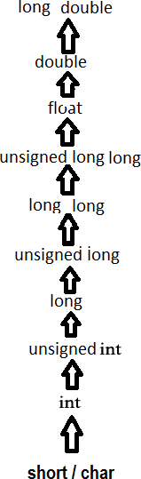
The usual arithmetic conversions are implicitly performed to cast their values in a common type, C uses the rule that in all expressions except assignments, any implicit type conversions made from a lower size type to a higher size type as shown below:
Type Casting In C Language

DIFFERENCE BETWEEN TYPE CASTING AND TYPE CONVERSION
BASIS FOR  COMPARISO N | TYPE CASTING | TYPE CONVERSION
Definition | When a user can convert the one data type into other then it is  called as the type casting. | Type Conversion is that which automatically converts the one  data type into another.
Implemented | Implemented on two  ‗incompatible‘ data types. | Implemented only when two data  types are ‗compatible‘.
Operator | For casting a data type to another,  a casting operator ‗()‘ is required. | No operator required.
Implemented | It is done during program  designing. | It | is done explicitly  compiling. | while
Conversion type | Narrowing conversion. | Widening conversion.
Example | int x;  byte y;  …y= (byte) x; | int | float  y=a; // value in y=3.000. | x=3;  y;

Inbuilt Typecast Functions In C:
There are many inbuilt type casting functions available in C language which performs data type conversion from one type to another.

S.No | Typecast Function | Description
1 | atof() | Convert string to Float
2 | atoi() | Convert string to int
3 | atol() | Convert string to long
4 | itoa() | Convert int to string
5 | ltoa() | Convert long to string

Topic: Conditional Branching: Applying if and switch statements, nesting if and else,
use of break and Default with switch.

If, if-else, Case switch statements CONTROL STATEMENTS
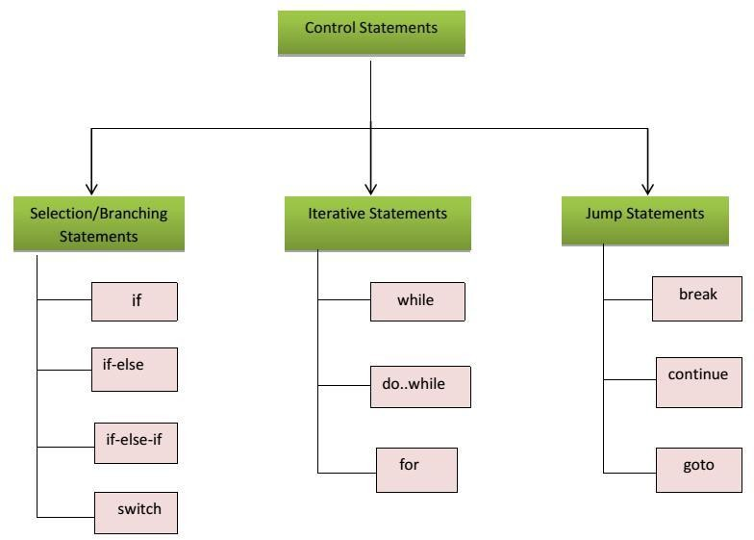
Control statements enable us to specify the order in which the various instructions in the program are to be executed. They define how the control is transferred to other parts of the program. Control statements are classified in the following ways:

a) If statement
Syntax:
if(boolean_expression)
{ /* statement(s) will execute if the Boolean expression is true */
}
If the Boolean expression evaluates to true then the block of code inside the if statement will be executed. If boolean expression evaluates to false then the first set of code after the end of the if statement (after the closing curly brace) will be executed. C programming language assumes any non-zero and non-null values as true and if it is either zero or null then it is assumed as false value.

Flow Diagram:
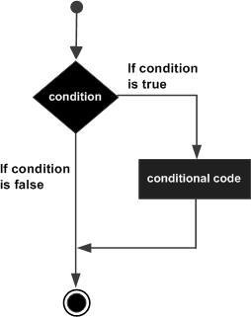
Example:
#include <stdio.h> int main ()
{ int a = 10; if( a < 20 )
{ Printf("a is less than 20\n" );
}
Printf("value of a is : %d\n", a);
}
When the above code is compiled and executed, it produces following result: a is less than 20;
value of a is : 10

if –else statement
Syntax: The syntax of an if...else statement in C programming language is: if(boolean_expression)
{ /* statement(s) will execute if the boolean expression is true */
}
else
{ /* statement(s) will execute if the boolean expression is false */
}
If the Boolean expression evaluates to true then the if block of code will be executed otherwise else block of code will be executed programming language assumes any non-zero and non-null values as true and if it is either zero or null then it is assumed as false value.

Flow Diagram:
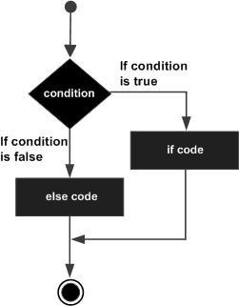
Example:
#include <stdio.h> main ()
{ int a = 100; if( a < 20 )
{ Printf("a is less than 20\n" );
}
else
{ Printf("a is not less than 20\n" );
} Printf("value of a is : %d\n", a);}
When the above code is compiled and executed, it produces following result: a is not less than 20;
value of a is : 100

Nested if-else statement
The syntax for a nested if statement is as follows: if( boolean_expression 1)
{ /* Executes when the Boolean expression 1 is true */ if(boolean_expression 2)
{ /* Executes when the Boolean expression 2 is true */
}
}

Example:
#include <stdio.h> main ()
{ int a = 100; int b = 200; if( a == 100 )
{ if( b == 200 )
{ printf("Value of a is 100 and b is 200\n" );
}
}
printf("Exact value of a is : %d\n", a ); printf("Exact value of b is : %d\n", b ); return 0;
}
When the above code is compiled and executed, it produces following result: Value of a is 100 and b is 200
Exact value of a is : 100 Exact value of b is : 200

A switch statement
Allows a variable to be tested for equality against a list of values. Each value is called a case, and the variable being switched on is checked for each switch case. Syntax:
switch(expression)
{ case constant-expression : statement(s);
break; /* optional */ case constant-expression :
statement(s);
break; /* optional */

/* you can have any number of case statements */ default : /* Optional */
statement(s);
}

The following rules apply to a switch statement:
- You can have any number of case statements within a switch. Each case is followed by the value to be compared to and a colon.
- The constant-expression for a case must be the same data type as the variable in the switch, and it must be a constant or a literal.
- When the variable being switched on is equal to a case, the statements following that case will execute until a break statement is reached.
- When a break statement is reached, the switch terminates, and the flow of control jumps to the next line following the switch statement.
- Not every case needs to contain a break. If no break appears, the flow of control will fall through to subsequent cases until a break is reached.
- A switch statement can have an optional default case, which must appear at the end of the switch. The default case can be used for performing a task when none of the cases is true. No break is needed in the default case.

Flow Diagram:
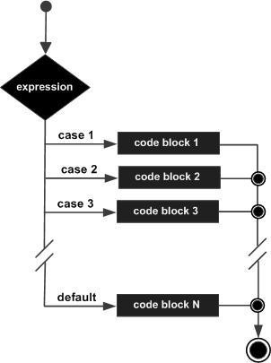
Example:
main ()
{ char grade = 'B'; switch(grade)
{ case 'A' : printf("Excellent!\n" ); break;
case 'B' :
case 'C' :
printf("Well done\n" ); break;
case 'D' :
printf("You passed\n" ); break;
case 'F' :
printf("Better try again\n" ); break;
default :
printf("Invalid grade\n" );
} printf("Your grade is %c\n", grade );
}
When the above code is compiled and executed, it produces following result:
Well done Your grade is B

Module – 3: (Loops & Functions)

Topic: Iteration and loops: use of while, do while and for loops, multiple loop variables,

use of break and

Program Loops and Iteration A loop statement allows us to execute a statement or group of statements multiple times and following is the general from of a loop statement in most of the programming languages:
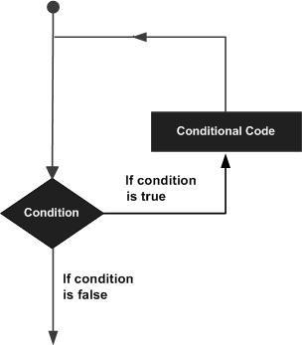

Uses of while loop
A while loop statement in C programming language repeatedly executes a target statement as long as a given condition is true.
Syntax: while(condition)
{ statement(s);
}
Here statement(s) may be a single statement or a block of statements. The condition may be any expression, and true is any nonzero value. The loop iterates while the condition is true.When the condition becomes false, program control passes to the line immediately following the loop. Flow Diagram:
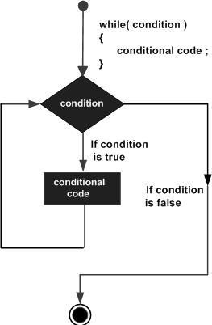
Example: #include <stdio.h> main ()
{ int a = 10; while( a < 20 )
{
printf("value of a: %d\n", a); a++;
}
}
When the above code is compiled and executed, it produces following result: value of a: 10
value of a: 11 value of a: 12 value of a: 13 value of a: 14 value of a: 15 value of a: 16 value of a: 17 value of a: 18 value of a: 19

Do-while loop
Unlike for and while loops, which test the loop condition at the top of the loop, the do...while loop in C programming language checks its condition at the bottom of the loop. A do...while loop is similar to a while loop, except that a do...while loop is guaranteed to execute at least one time. Syntax:
do
{ Statement;
} while ( condition );
If the condition is true, the flow of control jumps back up to do, and the statement(s) in the loop execute again. This process repeats until the given condition becomes false. Flow Diagram:
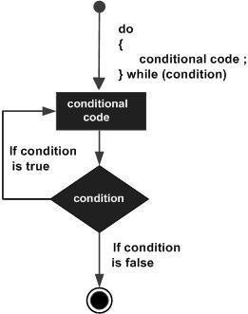
Example: #include <stdio.h>
main()
{
int a = 10;
do{
printf("value of a: %d\n", a);
a = a+1;
}
while ( a < 20 );
}
When the above code is compiled and executed, it produces following result:

value of a: 10
value of a: 11
value of a: 12
value of a: 13
value of a: 14
value of a: 15
value of a: 16
value of a: 17
value of a: 18
value of a: 19

For loops
for loop is a repetition control structure that allows you to efficiently write a loop that needs to execute a specific number of times. Syntax:
for ( initialization ; condition; increment )
{ statement(s);
}

Flow Diagram:
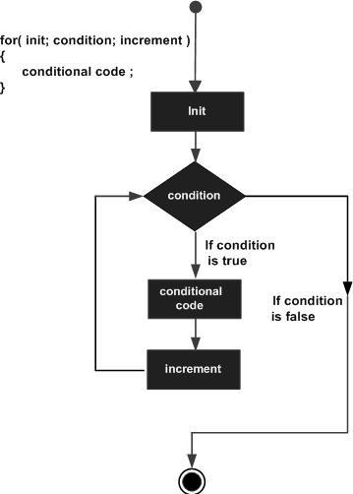
Example:
#include <stdio.h>
void main()
{
for(( int a = 10; a < 20; a = a + 1)
{
printf("value of a: %d\n", a);
}
}
When the above code is compiled and executed, it produces following result:

value of a: 10
value of a: 11
value of a: 12
value of a: 13
value of a: 14
value of a: 15
value of a: 16
value of a: 17
value of a: 18
value of a: 19

